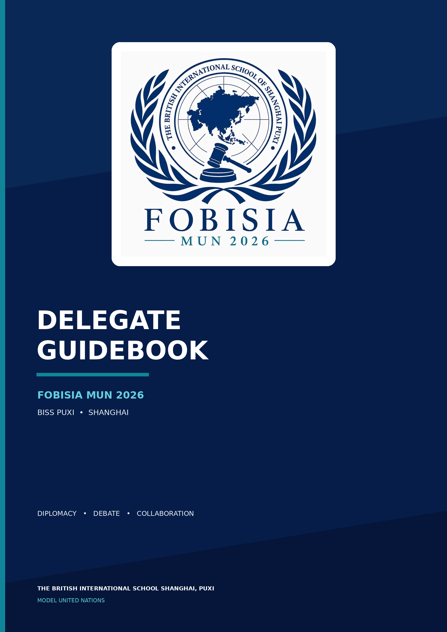

Table of content
What to bring
Conference expectations
Lobbying
Debating procedures
Points & Motions

Welcome to FOBISIA MUN

Welcome to the FOBISIA Model United Nations Conference!

Model United Nations is more than a debate. It is an opportunity to explore global issues, represent new perspectives, and work with others to find solutions to some of the world's most challenging problems. Throughout the conference, delegates will develop their skills in diplomacy, public speaking, negotiation, and collaboration.

Whether this is your first MUN conference or one of many, we encourage you to speak with confidence, listen with an open mind, challenge ideas respectfully, and make the most of every opportunity to participate.

This guidebook will introduce you to the key procedures, terminology, expectations, and essentials you will need throughout the conference. We hope it helps you enter your committee feeling prepared and ready to contribute.

We look forward to welcoming you to FOBISIA MUN and wish you an exciting and rewarding conference!

What to bring
To make sure you are fully prepared for the conference, we recommend bringing the following:
Conference essentials
- Laptop or tablet
o Used for lobbying ONLY
o Debates will be technology-free
- Laptop/tablet charger
- Notebook or notepad
- Pens and highlighters
- Conference badge / school ID, if required
- Water bottle
- Formal Attire

Committee Materials
- Position Paper
- Committee Background Guide
- Research notes
- Opening speech or speaking notes
- Key facts, statistics, and sources
- Notes on your country's position and policies
- Draft clauses or resolution ideas, if prepared

Dress code
- Business Attire (Including shoes)
- No jeans
- No trainers
- Tie & Blazer required for male delegates

Most importantly, come prepared to participate. It is not mandatory to know everything before entering the committee room. Research, listen carefully, speak when you can, collaborate with other delegates, and enjoy the conference.

Expectations
FOBISIA MUN aims to create a respectful, engaging, and professional environment in which every delegate has the opportunity to participate. Throughout the conference, delegates are expected to:

Participate Actively
Contribute to debate, raise POIs, participate in lobbying, and work with other delegates. You do not need to speak at every opportunity, but everyone is encouraged to make a meaningful contribution.

Debate Respectfully
Challenge ideas, not individuals. Listen when other delegates are speaking, use appropriate language, and remain respectful even when countries strongly disagree.

Collaborate
MUN is not simply about winning an argument. Work with delegates who share similar positions, negotiate differences, and contribute constructively to resolutions.

Use Technology Appropriately
Laptops and tablets may be used during lobbying only. Formal debates will be technology-free, so delegates should be prepared to use printed materials or handwritten notes.

Above all, be willing to participate, learn, and enjoy the conference.

Lobbying

Once lobbying begins, the chairs will ask delegates to divide into groups based on the topic delegates are focusing on. Delegates should follow the topic that they have chosen to prepare an opening speech on.
If the group of delegates is too big (different for each committee – follow your chair’s suggested number), breaking up into smaller groups would be ideal.
When deciding groups, ensure that you are selecting delegates with similar country stances, NOT SIMPLY BASED ON HOW FAMILIAR YOU ARE WITH THE OTHER PERSON.

Once in a group, the following is suggested:
1. Make a shared document & paste in all your clauses
2. Create a platform for communication – WeChat/teams/Instagram
3. Introduce yourselves

There is no need to maintain formal language during lobbying sessions; you can speak casually and build friendships. However, please ensure to maintain focused on resolution writing.
The requirement for a FOBISIA MUN resolution to be sent to the approval panel is to include 3 preambulatory clauses and 5 operative clauses (reference the resolution section for more information).
Once finished with the resolution, please decide on a main submitter to represent the resolution. The main submitter should be able to:
• Represent the resolution/group of delegates
• Create and give speeches on the resolution
• Accept/answer POIs from other delegates
• Contribute to the lobbying session
Please do not feel stressed to become the main submitter, being a co-submitter does not stop you from participating in debates!

Main submitter:
If you are decided as the main submitter, you should do the following
preparations.
• Prepare a 2-minute speech on your resolution
- Ensure you are fully aware with the resolution (Ask your group any unclear questions)
- Be ready to accept questions from the other delegates during debate
- Suggested to do more research on topic/organizations/policies that may
- help you to answer questions
- Be able to represent the stances and opinions of your co-submitter nations

Debate Procedure
Once debate starts, Admins will hand out copies of the resolution and the chairs will announce the commencement of reading time according to the length of the resolution.

Delegates are forbidden to crosstalk during this stage of debate
After the reading time, the main submitter is required to give a for speech for the resolution introducing the resolution with a supporting attitude while persuading the house to vote for the resolution as a whole.

Amendments
During and after reading time delegates can begin drafting their amendments and sending it to the chair with assistance of admins.

When the chair announces,
“The floor is now open to any delegate who wishes to make an amendment on the resolution or to give a for or against speech”

Delegates can raise their placards, if chosen then introducing their amendment or giving speeches on the resolution on stage.

Delegates are only allowed to make an amendment on parts of the resolution if it is approved by the chairs.

There are also 2nd degree amendments. 2nd degree amendments are raised when you want to modify the original amendment. 2nd degree amendments are ONLY entertained during time against the amendment, so make sure to carefully listen when your chair announces about the time against.
When debating for an amendment, the chair will set a “closed debate time” with a specific number of speeches for and against speeches. During this time, make sure to pay attention to your chair’s announcements about moving into different sections of the debate.

VOTING:
During voting time, your chair will make some instructions. To summarize,
there are two main instructions:
1. 2. You may not pass notes with other delegates during voting procedures.
You cannot leave the committee while the house is voting on an
amendment or a resolution.
There are three different ways you can vote:
1. Voting for
2. Voting against
3. Abstaining (not voting for or against, otherwise can be said as ‘neutral’)
** There are no such choices as ‘not voting’.
**Do not clap when an amendment is passed
**Do clap when the resolution as a whole passes

Points & Motions
POINTS:
- Point of Order
A point of order is raised when the delegate believes that another person on the committee is not correctly following the procedures.
- Point of Personal Privilege
Raised when a delegate is experiencing any form of discomfort (e.g. room temperature, visibility, ability to hear other delegates etc.).
- Point of Parliamentary Inquiry
This point is raised when the delegate needs further clarification about a procedure.

A delegate normally raises their placard and says something such as:
“Motion for a 10-minute moderated caucus, with a 45-second speaking time, on the topic of humanitarian assistance.”

- Motion for a Moderated Caucus
Proposes a structured period of focused debate. The motion normally specifies the total duration, individual speaking time, and topic.
- Motion for an Unmoderated Caucus
Proposes a period of informal negotiation. Delegates can leave their seats, speak directly with one another, form blocs, and draft documents.
- Motion to Extend the Caucus
Requests additional time for the current moderated or unmoderated caucus.
- Motion to Enter Voting Procedure
Requests that the committee begin voting on the matter before it.

